PANGUNI UTHIRAM

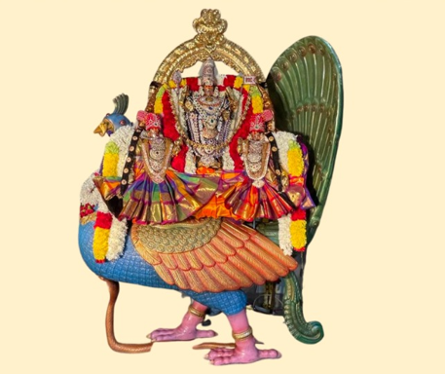

SUNDAY March 24, 2024 - 4:00 PM to 8:00 PM
AYYAPPA ABHISHEKAM,
SRI MURUGA ABHISHEKAM
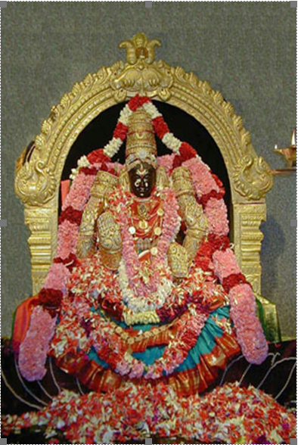

Monday March 25, 2024 - 09:30 AM to 11:00 AM
SRI LAKSHMI ABHISHEKAM

8:00 PM
SRI LAKSHMI UTHSAVAM SATHUMURAI

