**Sri Lakshmi Temple**

**117 Waverly Street, Ashland, MA 01721**

**Phone: 508-881-5775 Web:** [**www.SriLakshmi.org**](http://www.SriLakshmi.org)

**Solar Eclipse**

**5:48PM-7:37PM**

**on Oct 23, 2014 Thursday**

**Temple closed in the evening**

**The eclipse starts at one location and ends at another.**

**The times mentioned above are actual times when the eclipse occurs in Boston, MA.**

[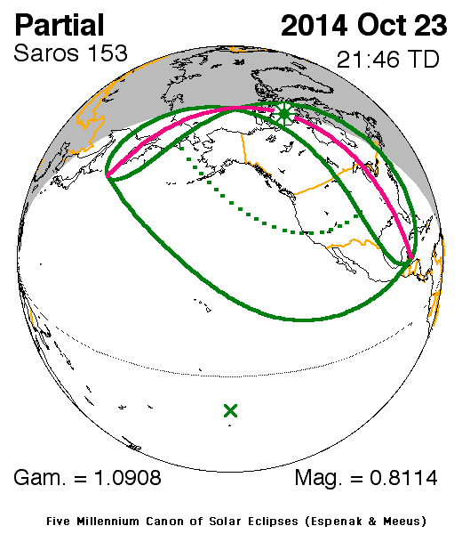](http://eclipse.gsfc.nasa.gov/OH/OH2014.html#SE2014Oct23P)

***Call Temple office at 508-881-5775 for more details***